Manual “Registration with Ed Controls”

What is Ed Controls?
Ed Controls is a digital tool where we register our quality and with which we record the premiliminary inspections and deliveries of our projects. It also allows us to quickly and clearly communicate identified shortcomings with out partners. This reduces the chance of miscommunication and speeds up the process.

Step 1: Registration
Before you can use Ed Controls you must first register your account. You can do this via your computer or mobile device (tablet/phone). It is important that you register with the e-mail address that is known to us. This is also the email address where you received the invitation or the preview. Did you receive the invitation at multiple email addresses? Then you can choose which email address you register yourself with.

It is important that you have registered yourself with Ed Controls.

In an internet browser, preferably Google Chrome or Firefox, go to web.edcontrold.com and click “Register”. On the next screen, enter your personal details and click “Register”.

You will now receive an email to confirm your account. This email may end up in your spam box.

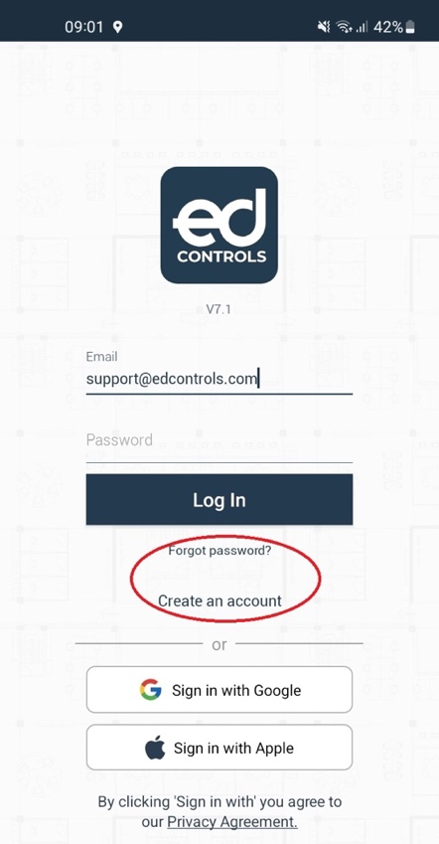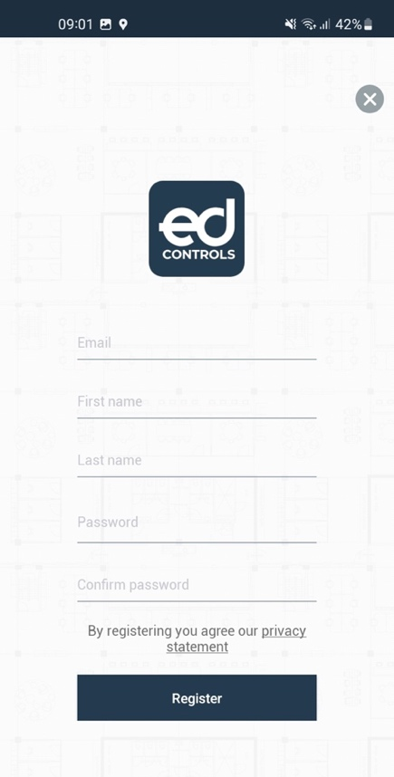
After the confirmation you will receive another email. You are now ready to use Ed Controls!

Step 2: Login on tablet and smartphone

Before you start with the preview of your home, it is wise that you have already installed the app on your tablet or smartphone.

After logging in to the app with your email address and password, download the project you want to work on to your device.

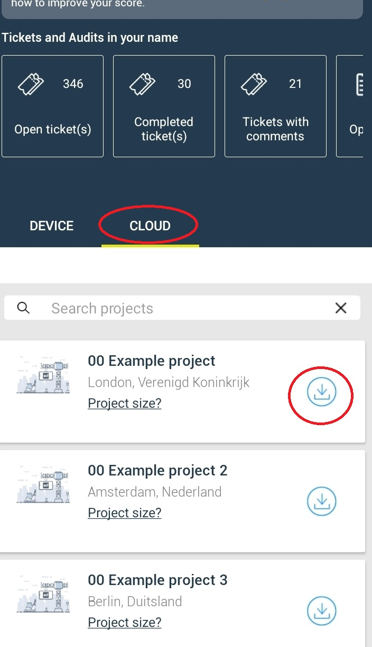

When you have access to the project, please select the drawing of the relevant floor on which you want to make the noted remark/defect. We have already prepared the drawings of your home for you to select.

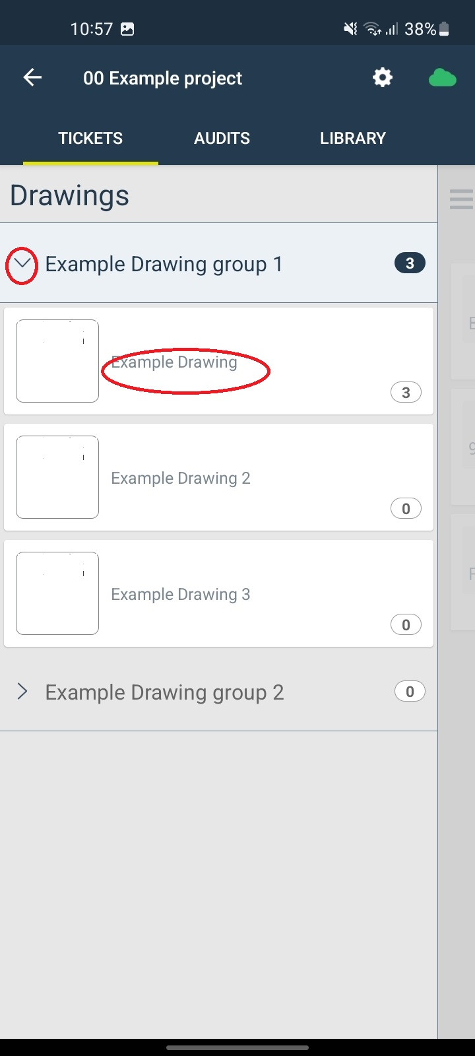

Step 3: Note noted remarks/defects

Now that you have selected the drawing, you can navigate through the drawings by moving your fingers across the screen.

Tap the location where you want to make a comment/defect.

When you tap on a point, your phone's camera will appear.

Take a picture of the point about which you want to comment/defect.

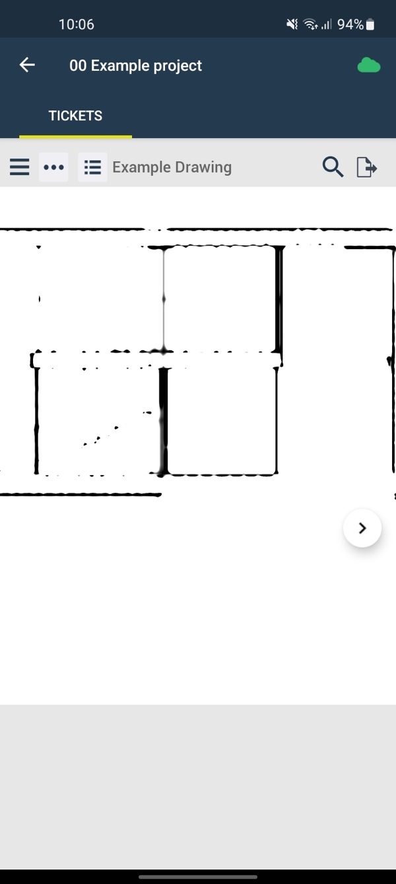

The screen will then look like this:

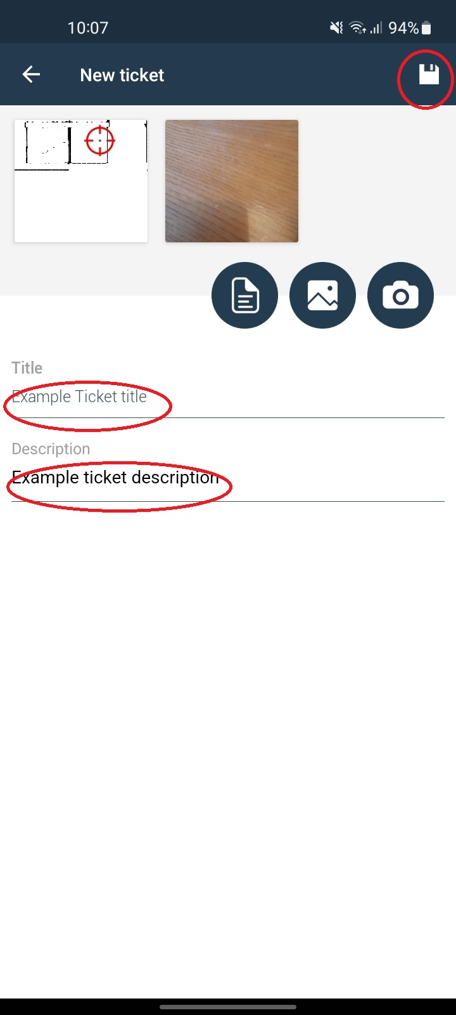

Fill in the title with the object it is about. For example: windowsill, frame, tiles, sanitary etc.

Then enter in the description what the remark or defect concerns.

Finally, press save.

If there are several comments/defects that you have found, repeat step three again.

Step 4: Finalize the preview

The orange spheres indicate the saved comments/defects.

By pressing the adjacent icon you will see an overview with the comments/defects made. You can check this list for completeness.

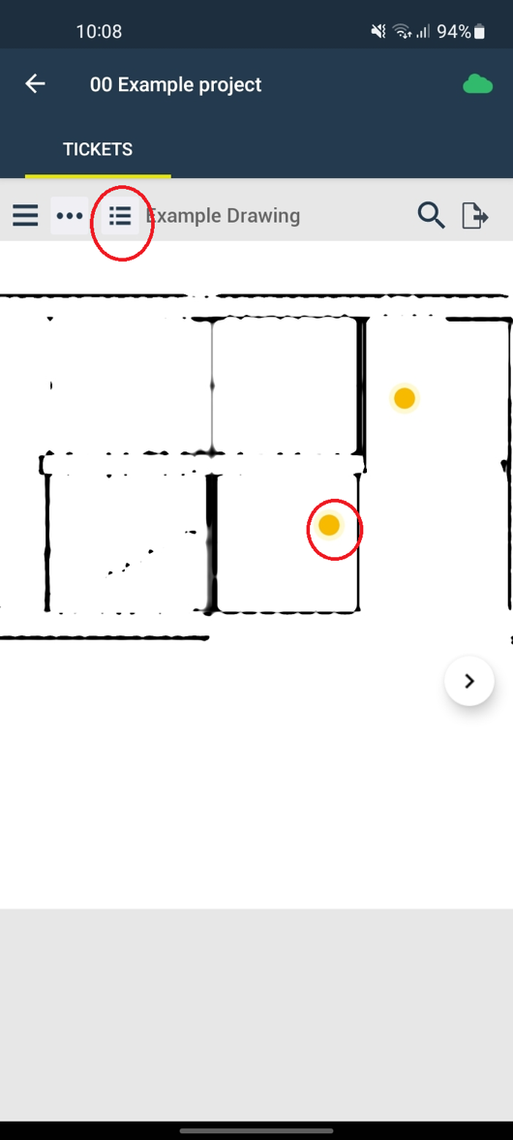

By pressing the following icon you can make a hard copy of the comments/defects made.

In the menu that appears, choose the printout: ''compact''.

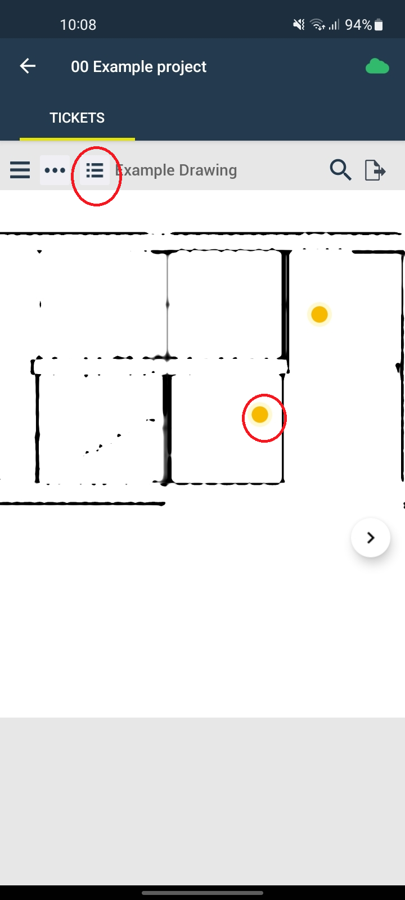

A .pdf file will then be sent to your email address with the summary of comments/defects made.

You can take this file with you to the delivery to check whether the comments/defects have been resolved.

We are immediately aware of the remarks/defects you have found. It is therefore not necessary to forward the comments/defects made to us.

Make sure you have the hard copy you made at hand during delivery to easily check whether the comments you made have been resolved.

We advise you to make a test remark/defect in advance so that everything runs smoothly during the preview.
Then also name this as: "Test".

