Dear Sir/Madame,

For the project '...', we have chosen to work with the software system ‘Ed Controls’. The use of Ed Controls for you is free of charge. We would like to receive from you the e-mail address that we can use for this project, for sending so-called 'tickets'. You can read more about this below. The e-mail address to be used can be passed on to the project manager.

What is Ed Controls?
Ed Controls easily records deficits, instructions or quality: with a photo (and text), linked to a position on a drawing. Tickets are stand-alone tasks that are sent directly to the responsible person via the system.

Why Ed Controls?
With Ed Controls, we can communicate with you faster and more easily about tasks and (recovery) work to be carried out. This reduces the risk of possible misunderstandings.

What do I have to do?
As our construction partner, you will receive a welcome message via e-mail with a link to the registration page on the Ed Controls website. Once you have clicked on the confirmation link, your registration is complete. After logging in, you can view, print and complete your tickets. You have access to both the Ed Controls web page and the app, which you can use on your smartphone or tablet. Please use the e-mail address given to us for this purpose.

- Once you have registered, you will be able to view your tickets.
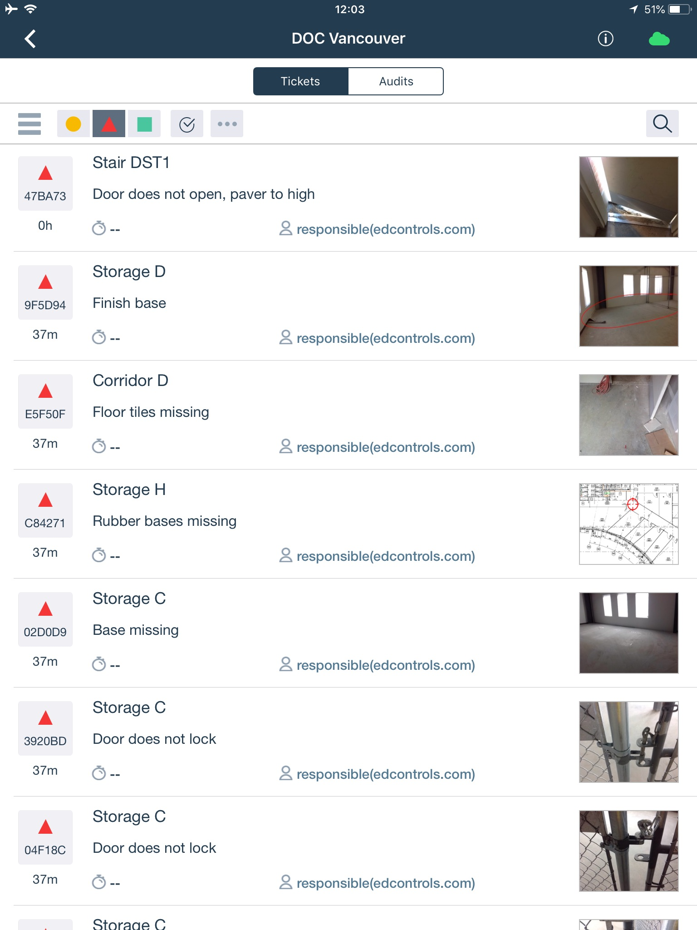

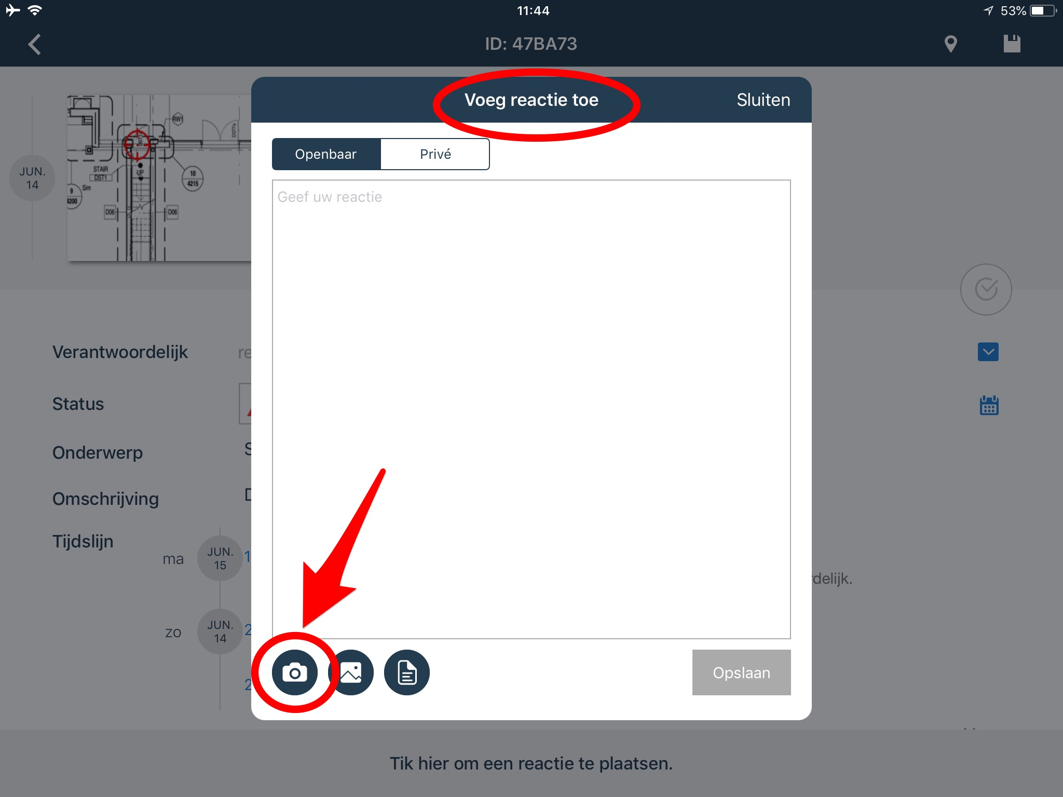
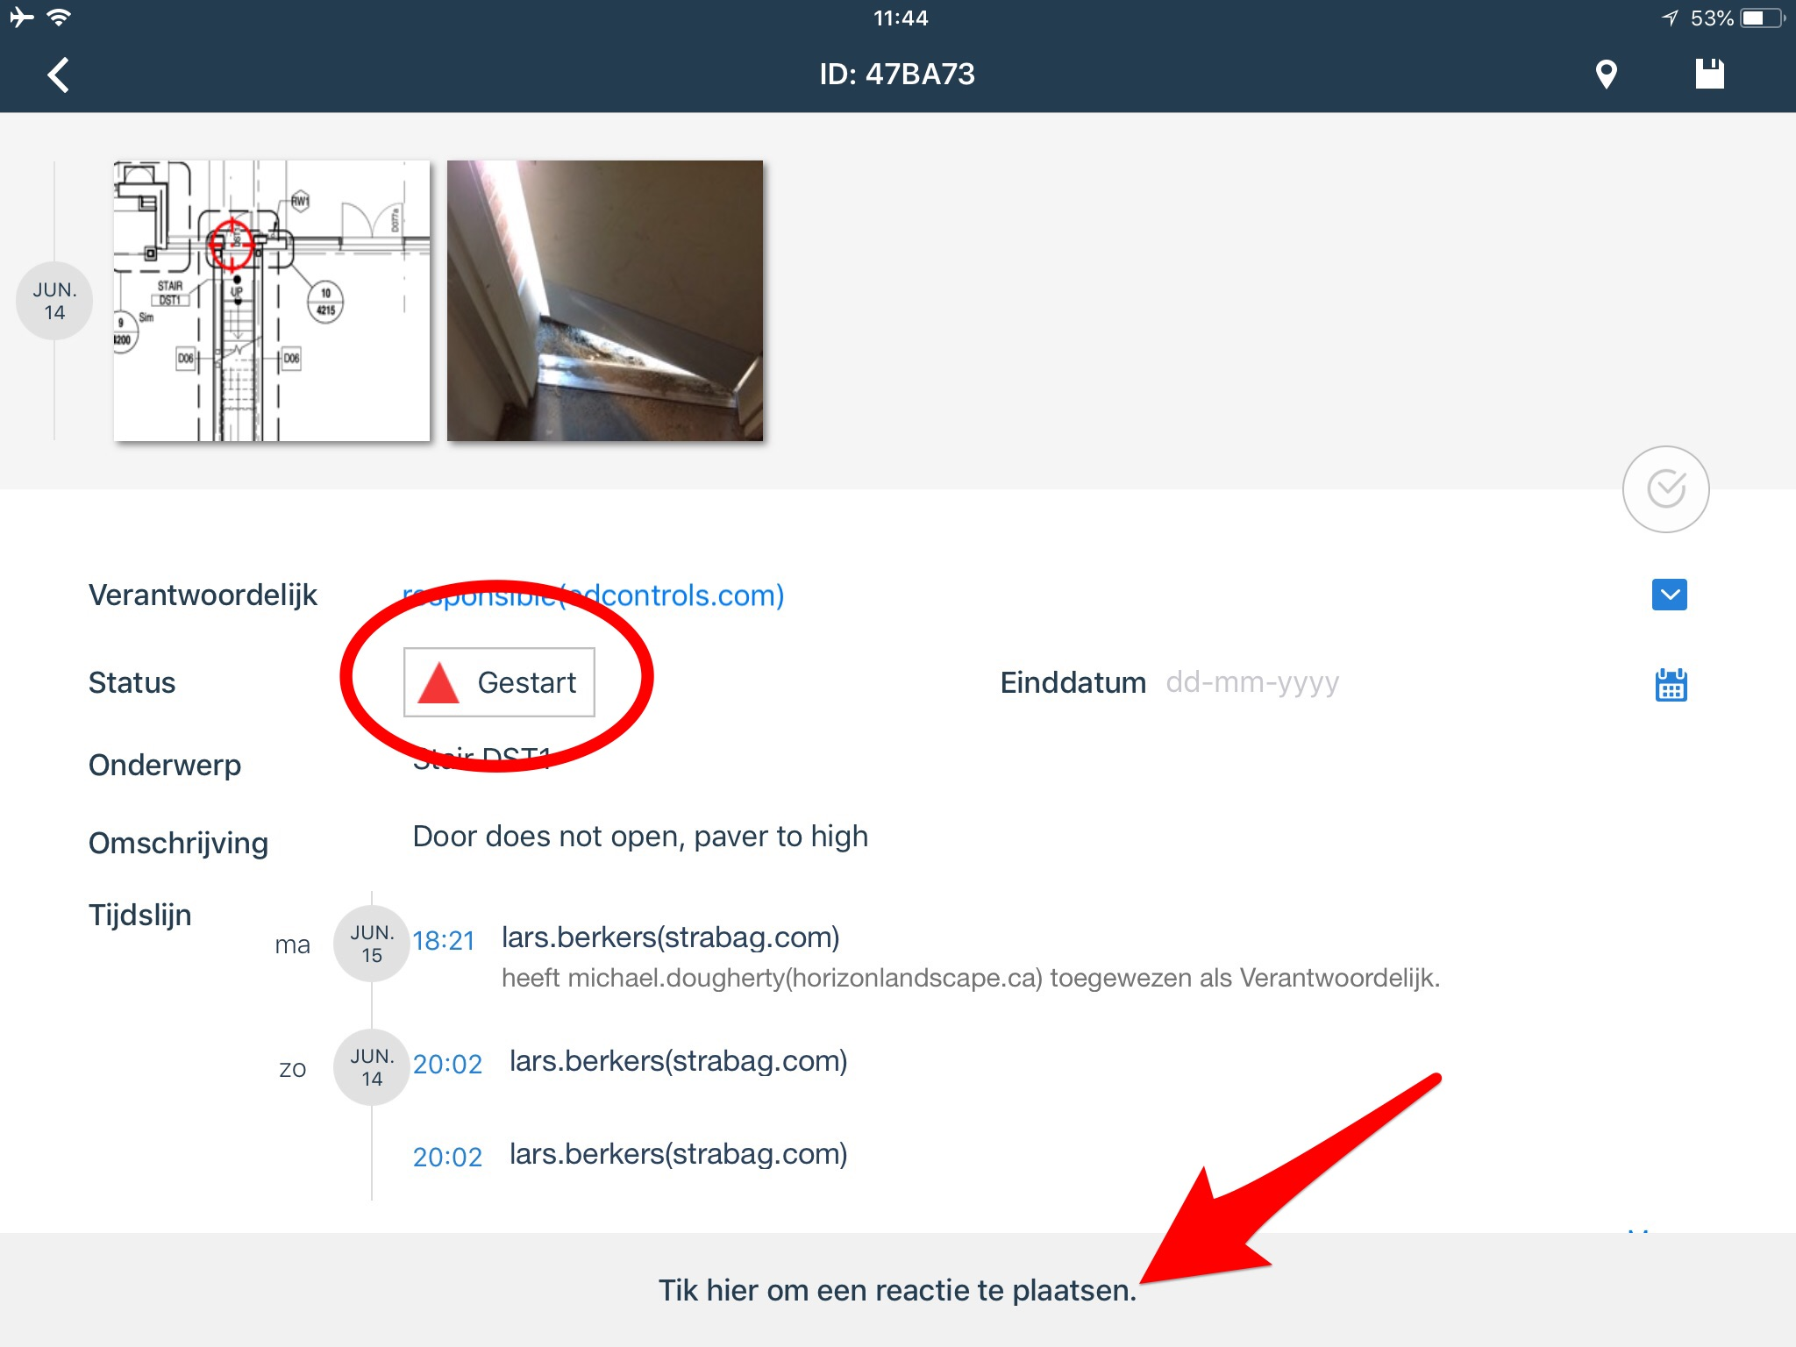
- The tickets you see are in the 'started' status and are marked as red triangles.

- If necessary, you can also add a photo and a comment to the ticket in order to record the work carried out.
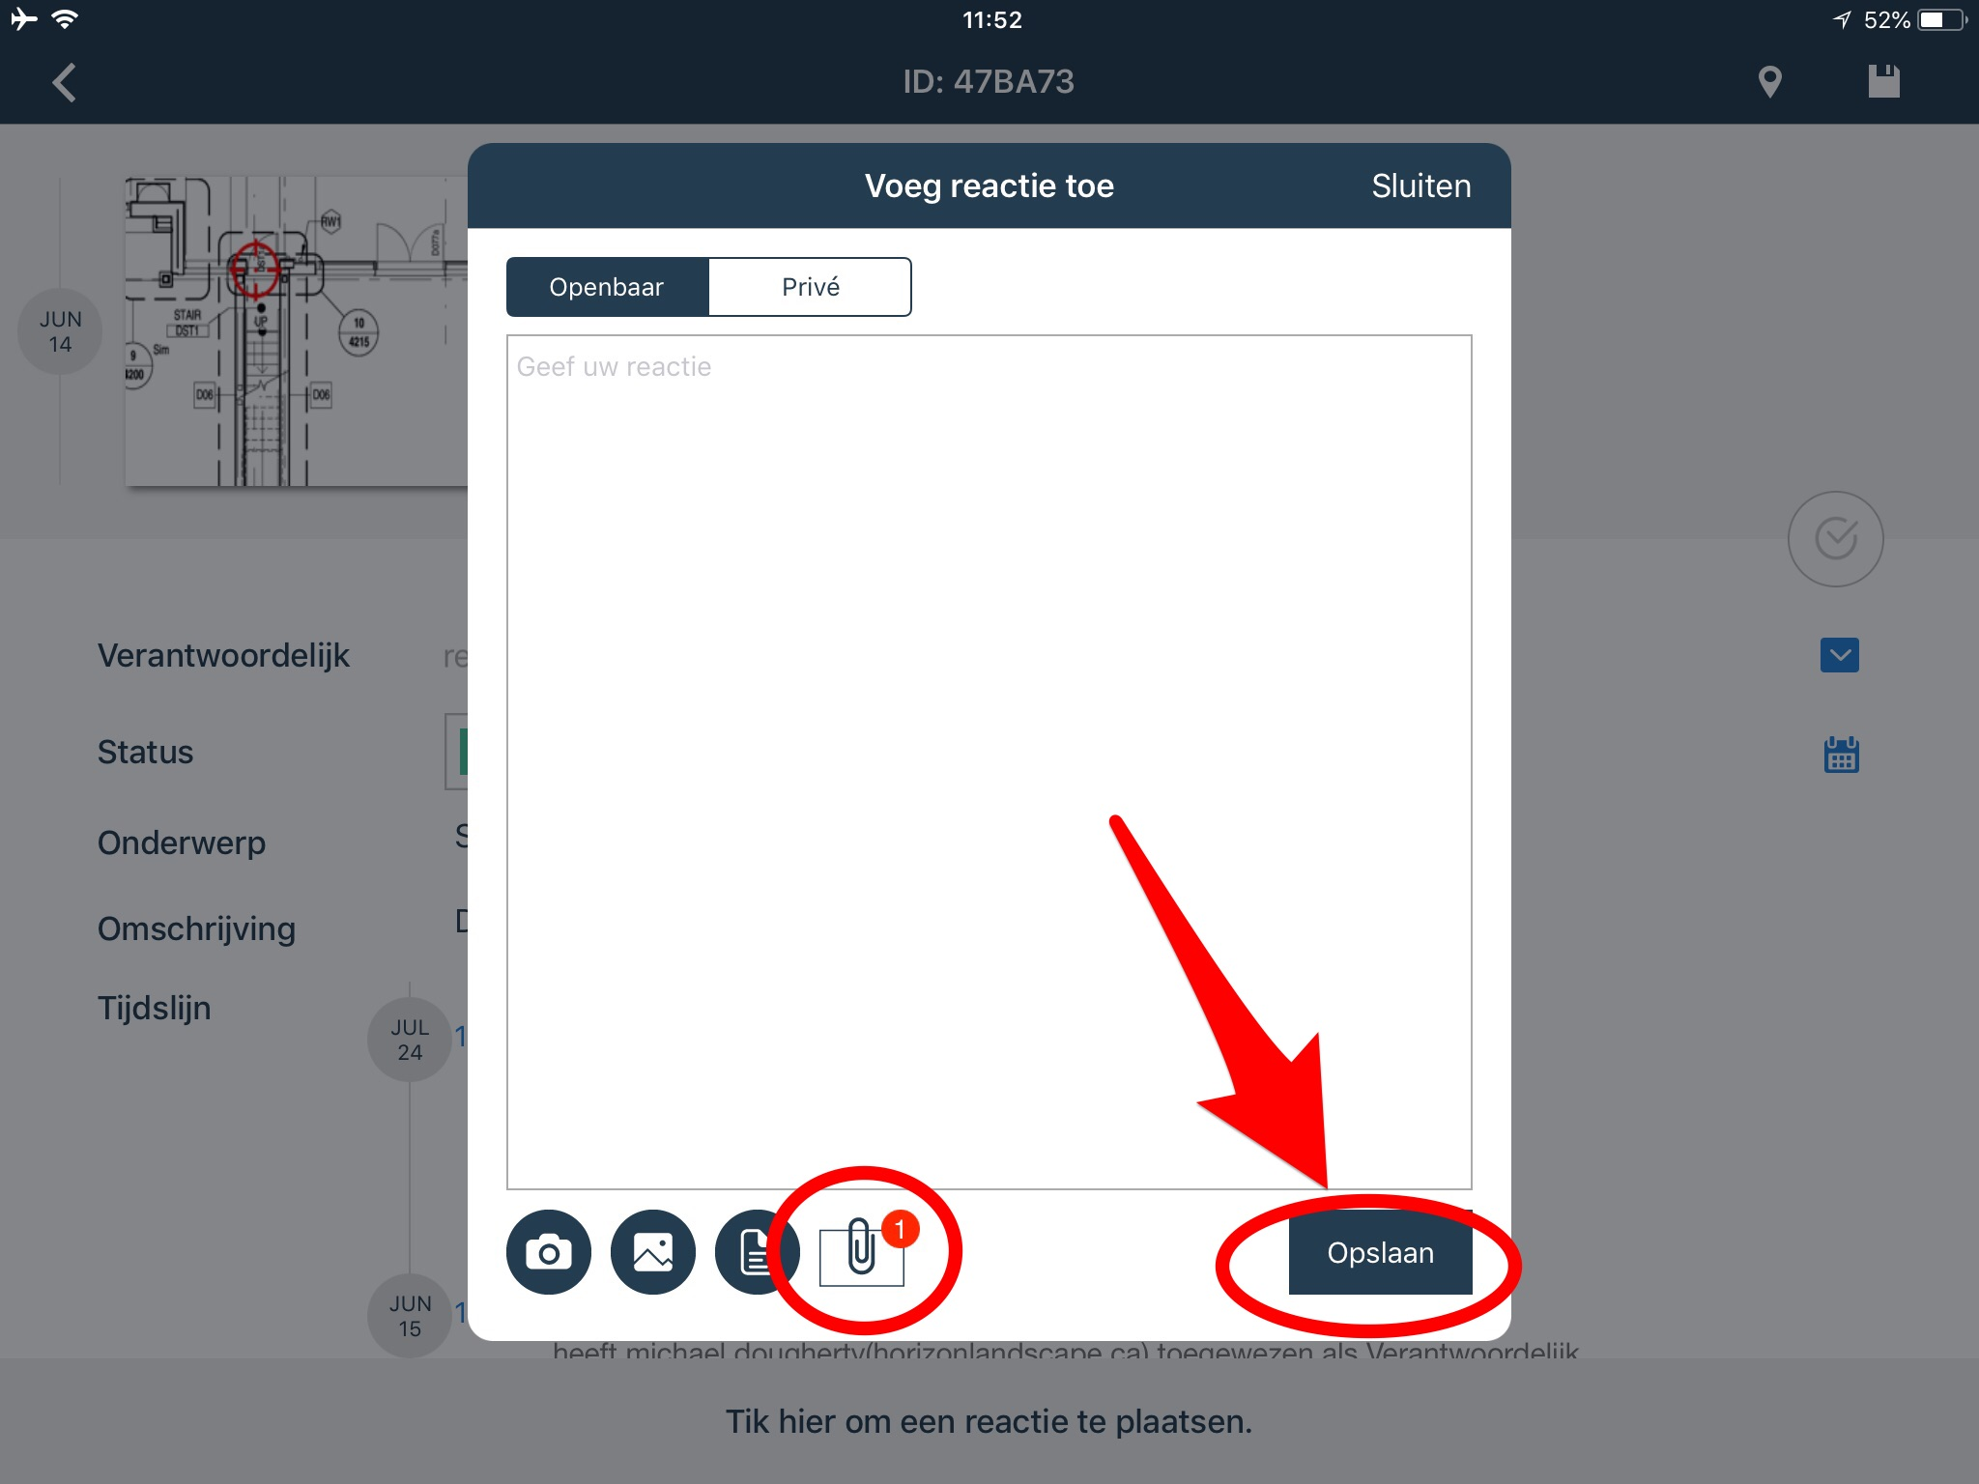
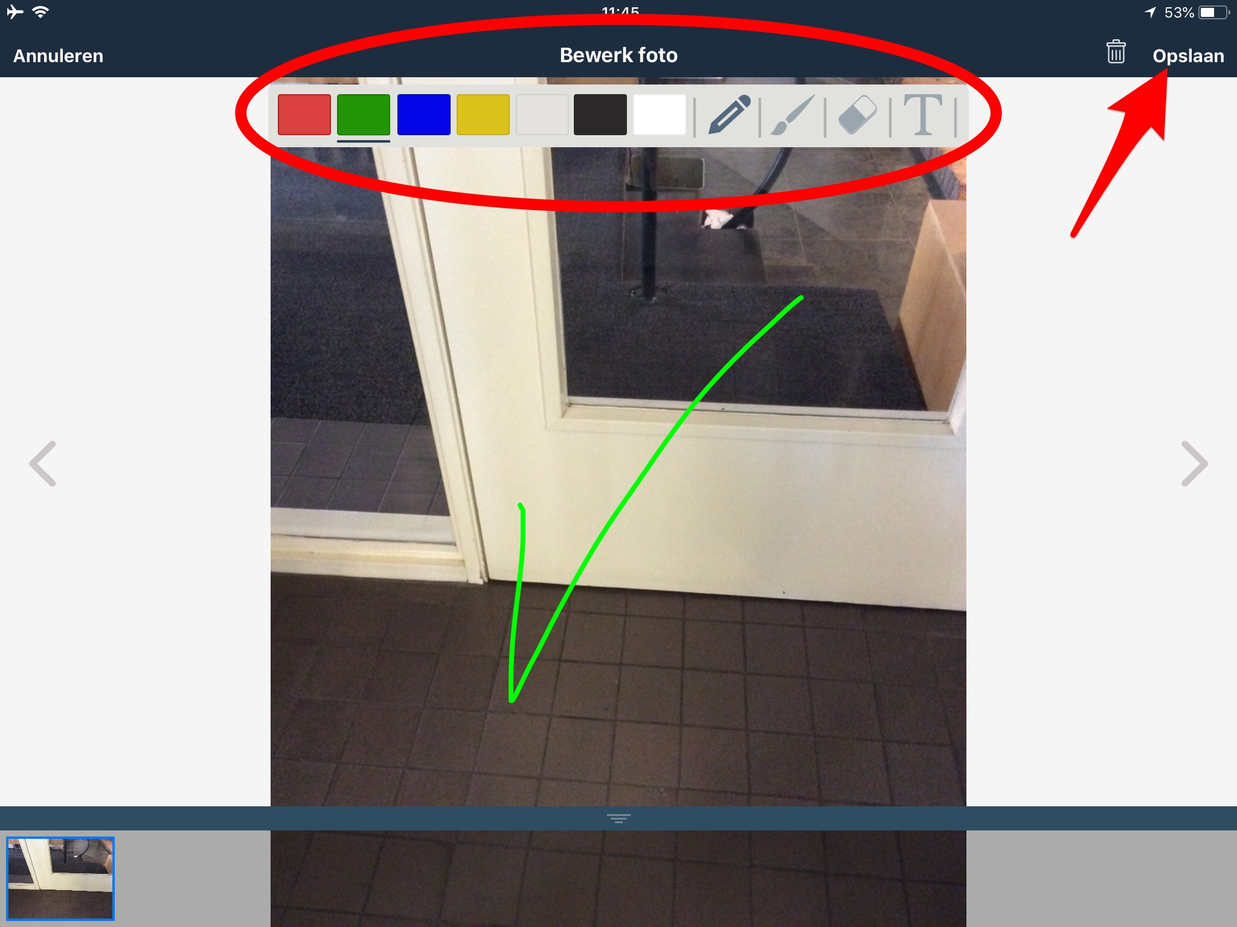

- After you have carried out the work, change the status of the tickets to 'completed' and click on 'save'. This will change the symbol to a green square.
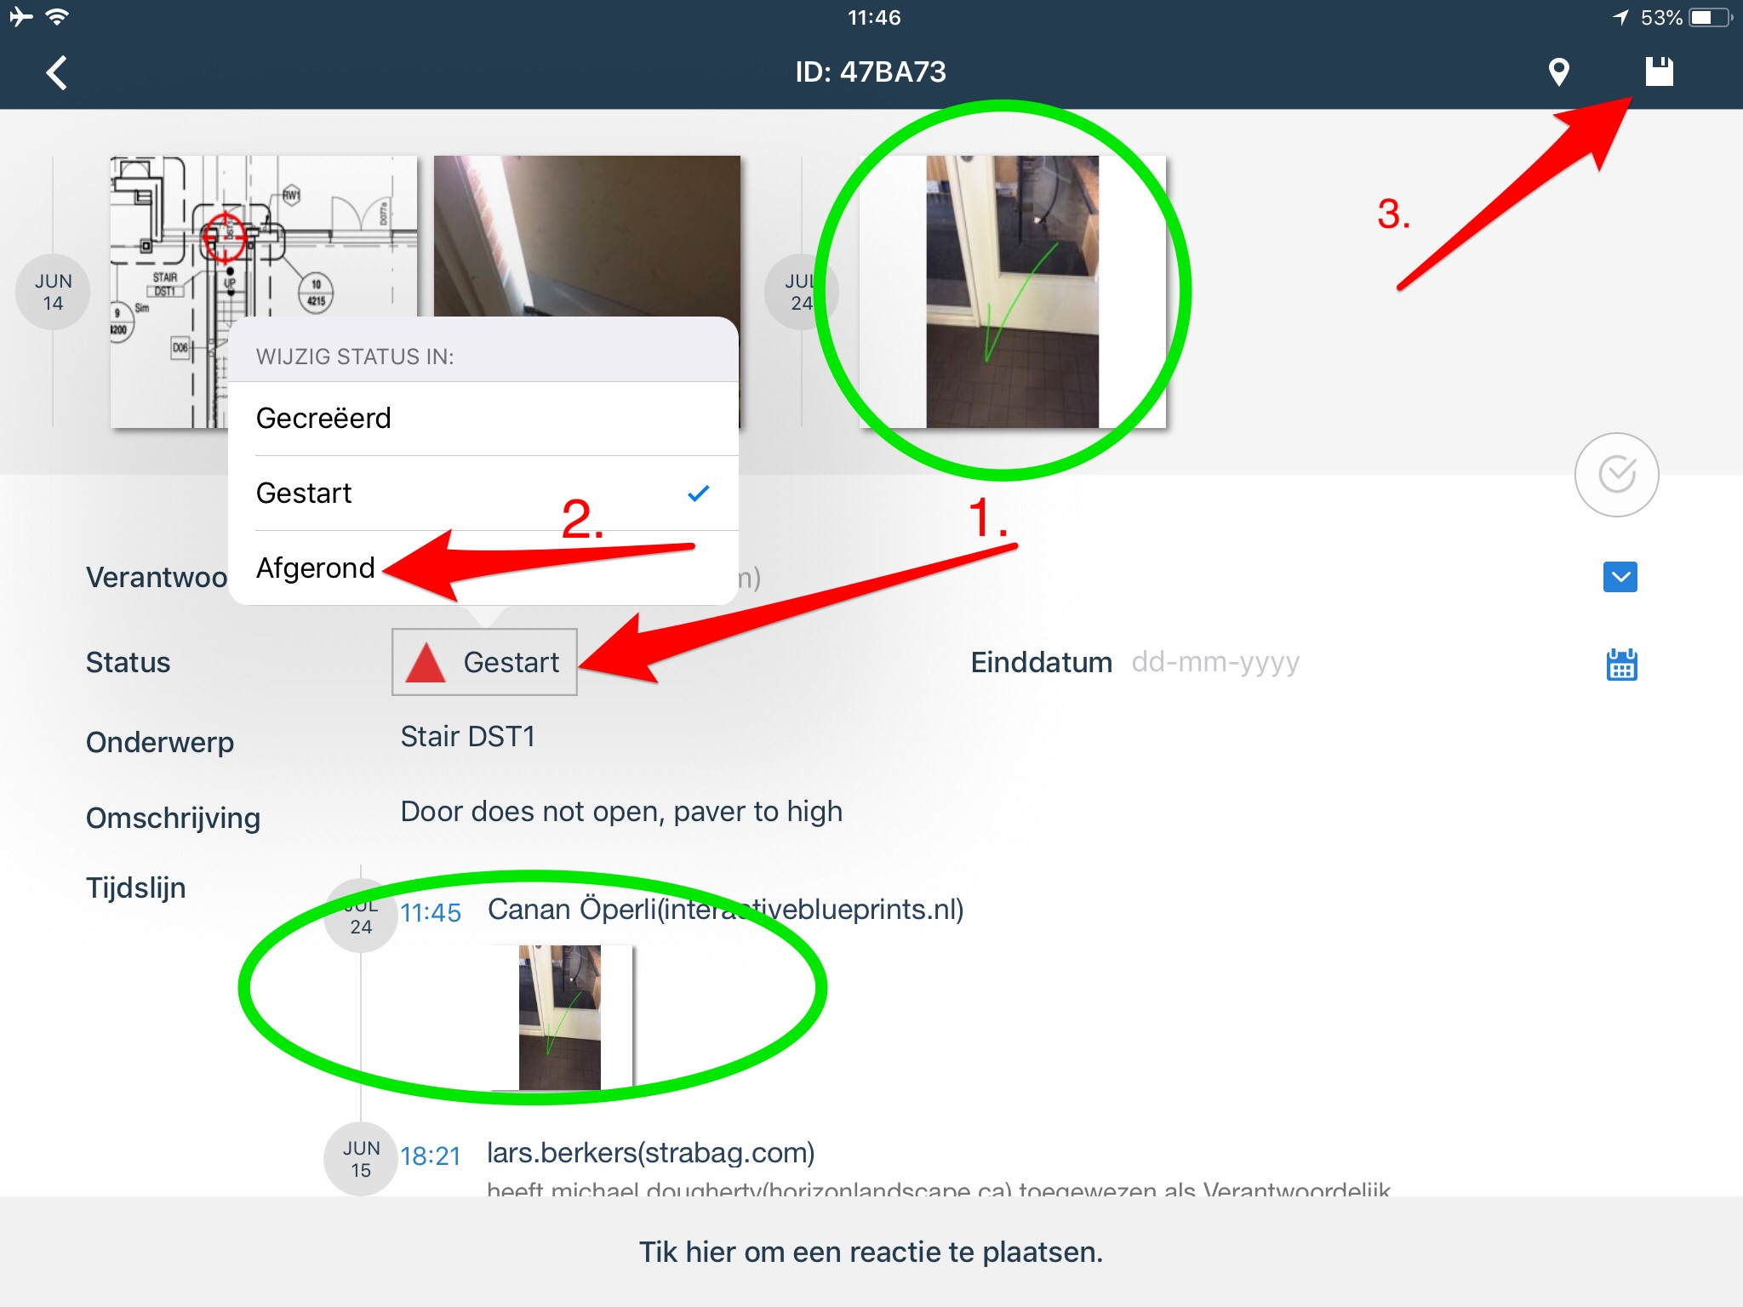

When the work is approved, we will archive the ticket. If any changes need to be made to the work delivered, you will receive a notification via e-mail.

Forward a ticket to your own construction partners
It is possible that you have someone else solve a ticket for which you are responsible. You can do this in Ed Controls by adding that person to the ticket as a Consultant.

It works as follows: the Responsible of a ticket can add a Consulted to this ticket. This Consultant will receive a notification and can get started. When the Consulted has done the work, he or she adds photos and text to the ticket. As soon as the Responsible sees that the Consulted has performed the work correctly, he or she can report the ticket as ready. In this way, the Responsible can work better together and complete a ticket more quickly without having to be present on location.

IMPORTANT: This functionality relates to the (web) app of Ed Controls and is therefore only available within Ed Controls. It does not allow you to forward a ticket to a partner who does not use Ed Controls.
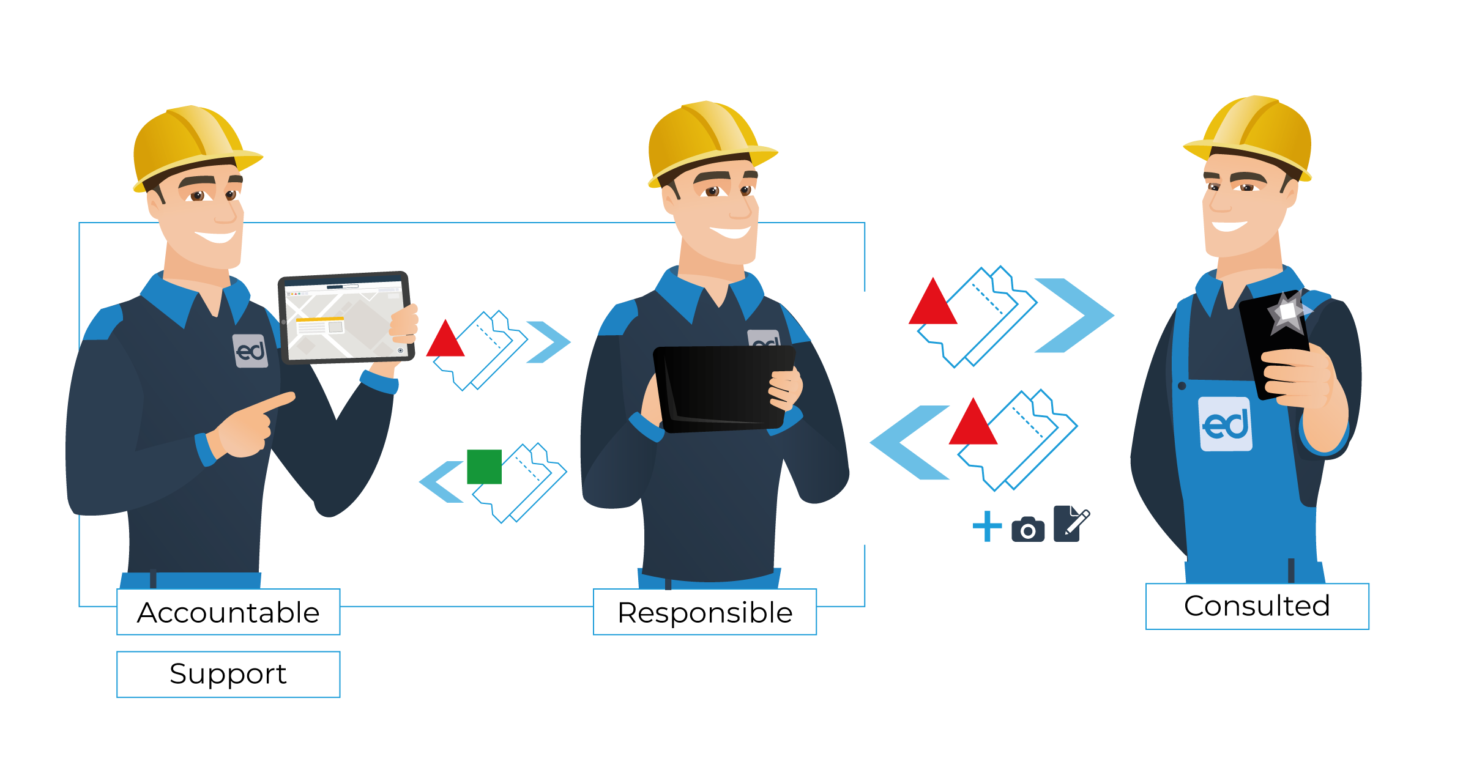
Simply download the Ed Controls App from the AppStore or Google Play Store to view and complete your tickets. The App is available for smartphones and tablets. Alternatively, you can also view the tickets via the browser on your PC.

For technical questions, you can reach the Ed Controls team directly by calling +44 (0)20 3868 1867 or by e-mail to helpdesk@edcontrols.co.uk.

We look forward to a successful cooperation with you and Ed Controls!

